Interfacing DC motors with Arduino

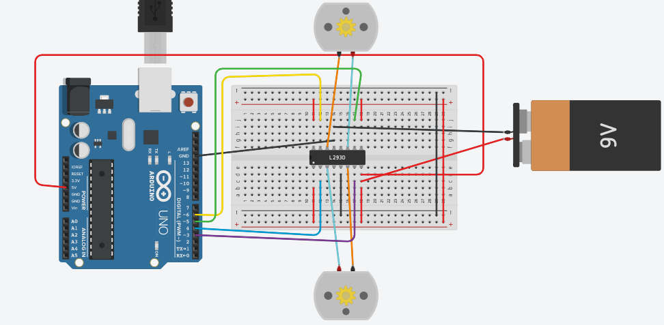

Code:

const int pwm = 2 ; //initializing pin 2 as pwm

const int in_1 = 8 ;

const int in_2 = 9 ;

//For providing logic to L298 IC to choose the direction of the DC motor

void setup() {

pinMode(pwm,OUTPUT) ; //we have to set PWM pin as output

pinMode(in_1,OUTPUT) ; //Logic pins are also set as output

pinMode(in_2,OUTPUT) ;

}

void loop() {

//For Clock wise motion , in_1 = High , in_2 = Low

digitalWrite(in_1,HIGH) ;

digitalWrite(in_2,LOW) ;

analogWrite(pwm,255) ;

/* setting pwm of the motor to 255 we can change the speed of rotation

by changing pwm input but we are only using arduino so we are using highest value to driver the motor */

//Clockwise for 3 secs

delay(3000) ;

//For brake

digitalWrite(in_1,HIGH) ;

digitalWrite(in_2,HIGH) ;

delay(1000) ;

//For Anti Clock-wise motion - IN_1 = LOW , IN_2 = HIGH

digitalWrite(in_1,LOW) ;

digitalWrite(in_2,HIGH) ;

delay(3000) ;

//For brake

digitalWrite(in_1,HIGH) ;

digitalWrite(in_2,HIGH) ;

delay(1000) ;

}

